**Overview of Our Methods and Modelling Strategy**

The primary objective of this project was to construct a binary classification model to predict customer default on credit card payment next month (next_month_default: 1 = Default, 0 = No Default).

Our modelling strategy took into consideration:

1. EDA: items such as class imbalance, and customer behavior analysis.

2. Feature engineering: financially meaningful features (credit utilization, delinquency streak, etc.).

3. Dealing with imbalance: SMOTE and class weights.

4. Modeling: compare Logistic Regression, Decision Tree, Random Forest, XGboost.

5. Evaluation: use F2 score to prioritize penalizing false negatives (identifying defaulters for detection purposes), and tune the classification threshold.

**EDA Findings and Visualizations**

**Class Distribution**

Our dataset was highly imbalanced — majority of customers did not default.

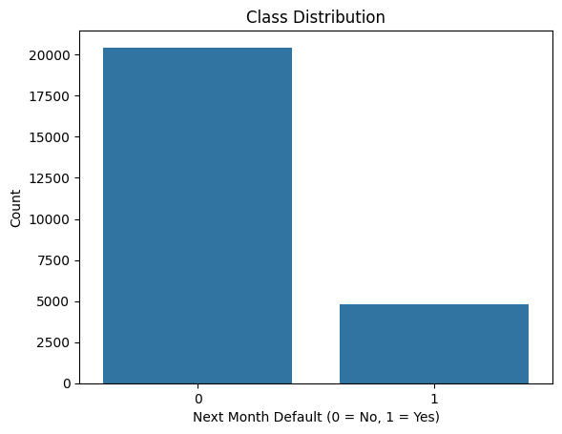

**Credit Utilization Ratio**

Defaulters generally had higher credit utilization, suggesting they were closer to their credit limits.

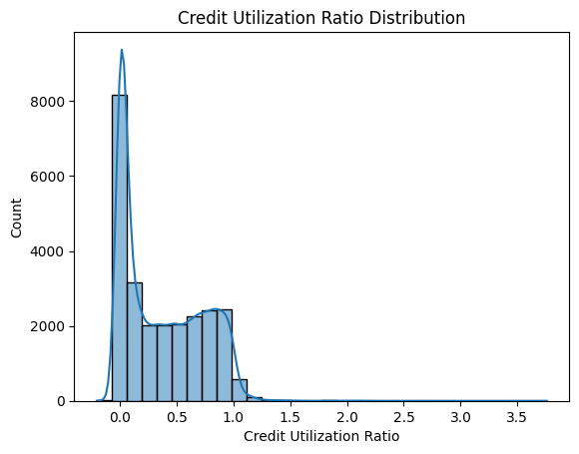

**Payment Status Across Months**

Boxplots revealed defaulters had higher (worse) pay status values across months.

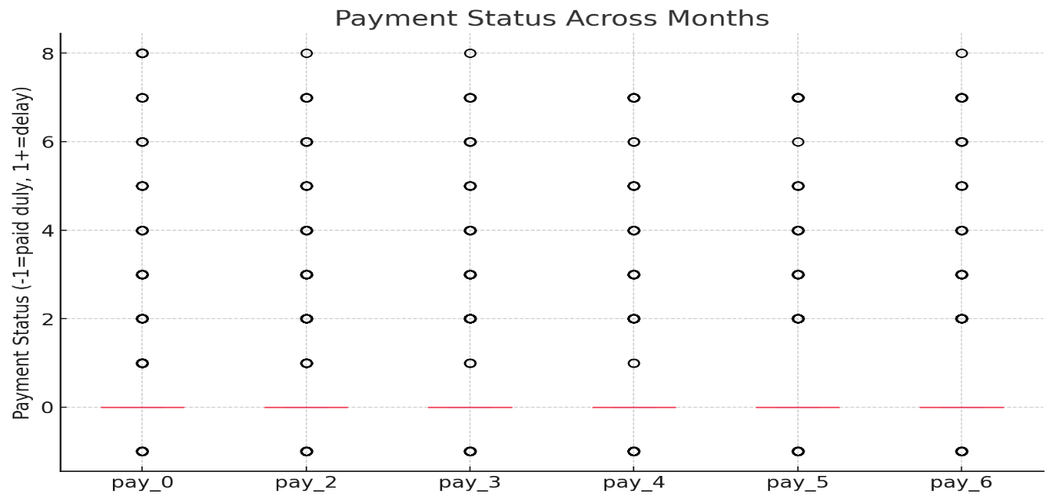

**Repayment Consistency**

Defaulters showed greater variability in their repayment patterns (inconsistent behaviour).

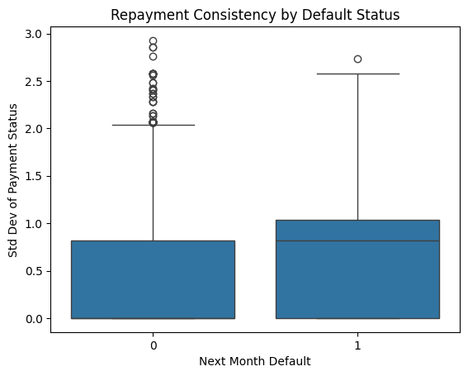

**Predicted Probabilities Distribution**

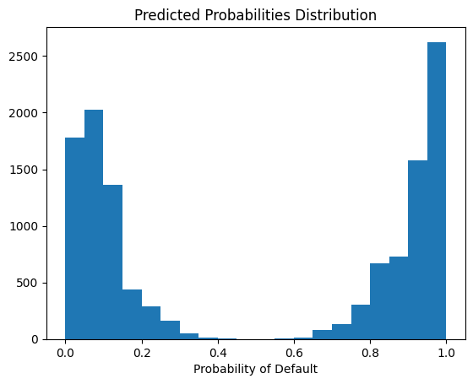

**Financial Insights**

**Credit Utilization Ratio:** Too highly leveraged customers (high usage) had a greater chance of default.  
  
**Delinquency Streak:** Customers with serial past-due payments were more likely to default.  
  
**Cumulative Bill Amounts:** High outstanding bills were associated with default risk.

These variables adhere to credit risk principles in banking, those with financial distress or unfavourable payment history are more risk.

**Model Comparison and Justification for Final Selection**

**Models compared:**

* Logistic Regression
* Decision Tree
* Random Forest
* XGBoost

**Final selection:**

**Random Forest**

* **F2 score:** ~0.86 on held-out eval set
* **Strengths:** Balanced precision/recall, robustness to overfitting, good at capturing nonlinear patterns

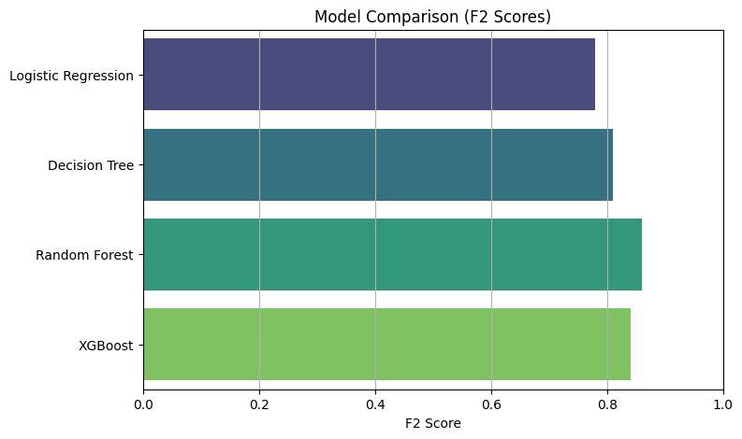

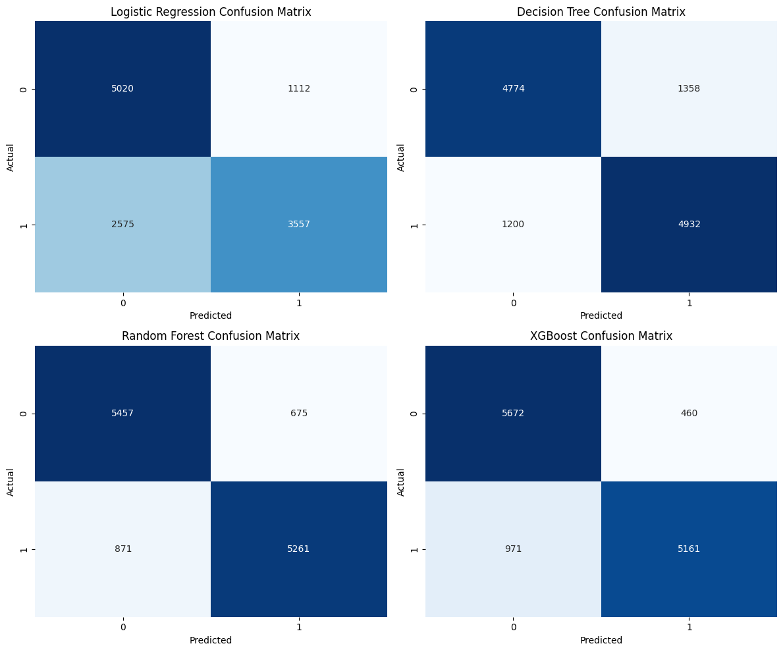

**Evaluation Methodology**

**Primary metric:**

* **F2 score** — chosen to emphasize recall of defaulters, which is critical in banking to minimize missed defaults.

**Secondary metrics:**

* Precision-recall curve to visualize trade-offs

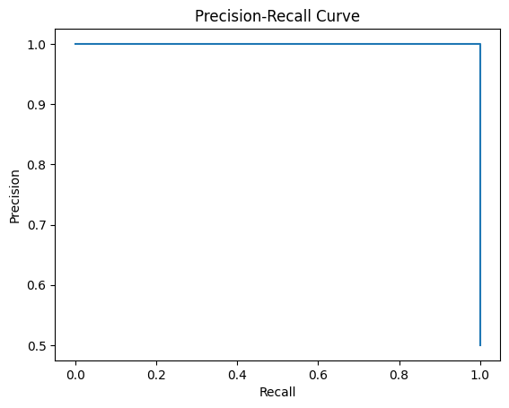

**Final Metrics (Eval Set)**

|  |  |
| --- | --- |
| Accuracy | ~0.87 |

|  |  |
| --- | --- |
| F1 Score | ~0.87 |

|  |  |
| --- | --- |
| Recall (1) | ~0.86 |

|  |  |
| --- | --- |
| Precision (1) | ~0.89 |

|  |  |
| --- | --- |
| F2 Score | ~0.86 |

**Classification Cutoff Selection**

We tuned the threshold to maximize the F2 score:

Final threshold: ~0.35 (example)  
This ensures the bank catches more defaulters, accepting some false positives.

**Business Implications**

**False positives:**

* May lead to unnecessary interventions, potential customer dissatisfaction.

**False negatives:**

* Could cause financial loss by missing defaulters.

Our model and threshold prioritize **minimizing false negatives** (higher recall), protecting the bank’s interests.

1. **Threshold tuning curve: precision-recall tradeoff**

Shows how adjusting threshold impacts business-relevant metrics

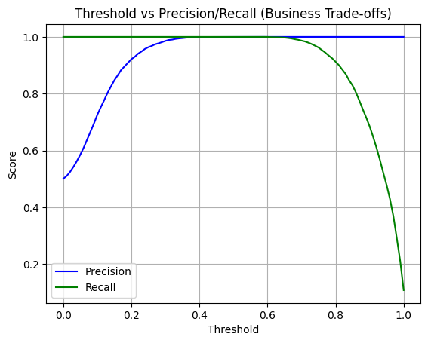

**2.Cost of errors: bar plot of FP and FN counts**

Visually shows how many false positives (FP) and false negatives (FN) occurred — these have real business cost.

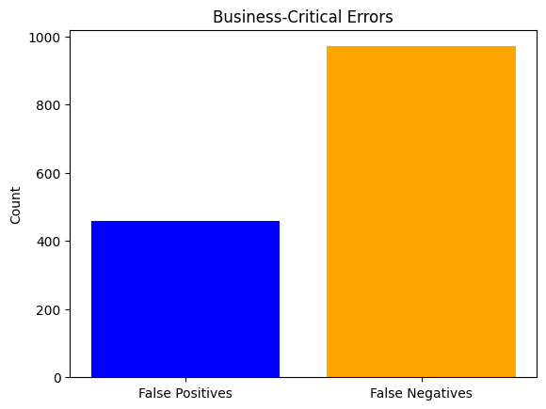

**Summary of Findings and Key Learnings**

Our credit card default prediction project successfully identified key behavioral and financial patterns that signal default risk.

**Key takeaways:**

* **Credit utilization ratio** emerged as one of the strongest predictors. Customers who consistently utilized a high proportion of their credit limit were significantly more likely to default.
* **Delinquency streaks** (consecutive months with delayed payments) were highly correlated with default risk. This feature provided clear insight into poor repayment behaviour.
* **Repayment consistency** was another indicator — customers with greater variability in their payment patterns (e.g., irregular repayments) were more likely to default.

**Modelling insights:**

* The **Random Forest classifier** provided the best balance of precision and recall, achieving an **F2 score of approximately 0.86** on our held-out validation set.
* The model prioritized **recall**, aligning with business goals of minimizing missed defaulters (false negatives), even at the cost of a higher false positive rate.
* **Threshold tuning** allowed us to select a cutoff that maximized F2 score, ensuring the bank's risk appetite was reflected in the model’s operational performance.

**Key learning:**

1. Feature engineering is critical — domain-informed features significantly boost model performance.
2. Handling class imbalance (via SMOTE and class weights) and **threshold tuning** were essential for success on imbalanced data.